pe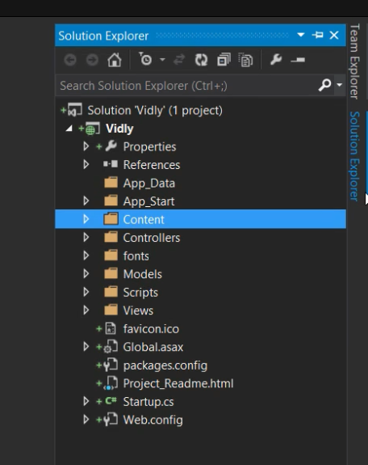

**App_Data** Here will be the database files will go.

**App_start** contains some classes which are called when application started.

**Content** folder have the static files.

**Controller** is self-explanatory.

**Font** contains fonts, (no idea why they even put it outside instead of inside Content ><)

**Models** self-explanatory.

**Scripts** here we store the JavaScript files.

**Views** here we have our views. The convention is, when we use any controller, asp.net will look for a folder with same name in views folder.

**Favicon** is our icon for the application displayed on the browser.

**Globar.asax** traditional file. A class that provides hooks for various events in application lifecycle. 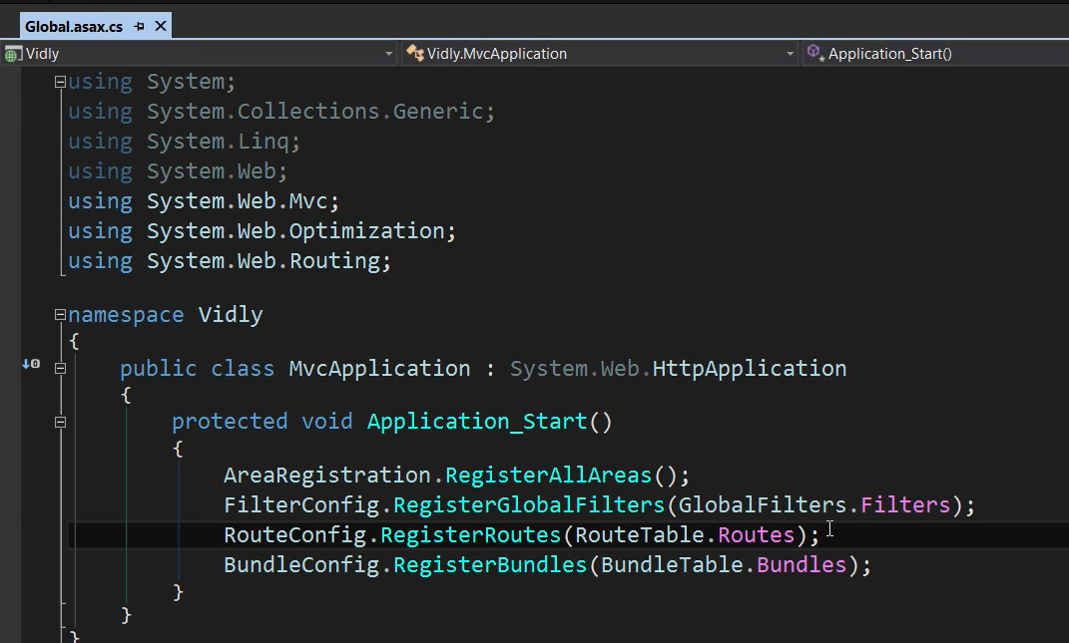

**Packages.config** is used by nuget pacakage manager.

**Startup.cs** is the new approach for starting the application instead of the global.asax.

**Web.config** xml file for our app configeration. Usually we are interested in only two elements. 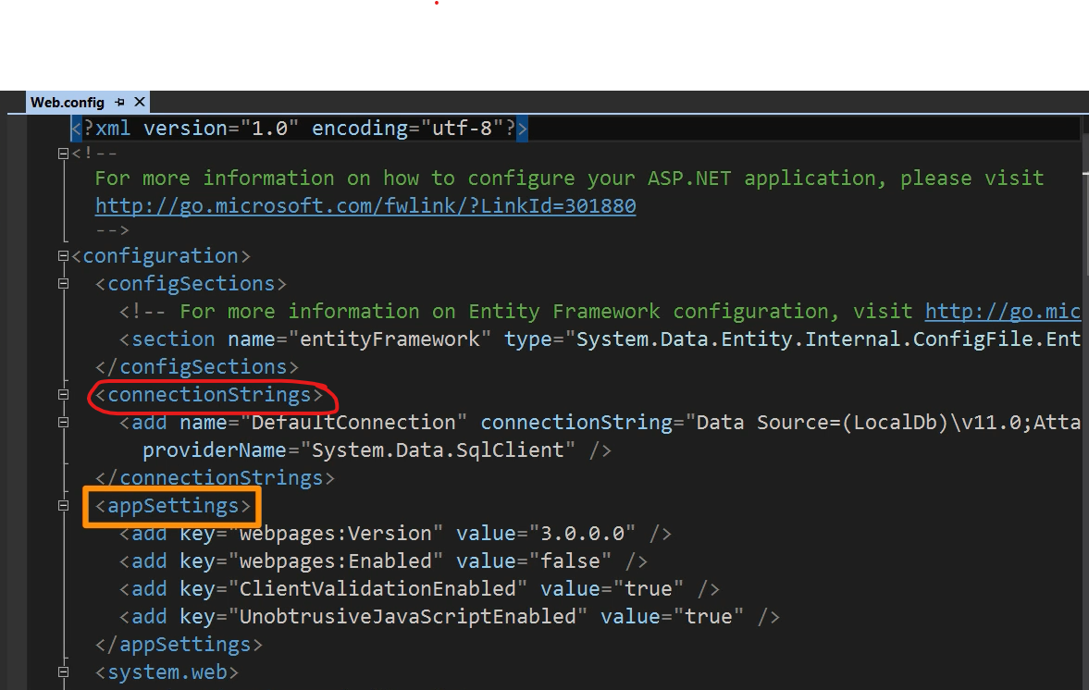

**connectionStrings**  is where we define our database connection.

**appSettings** is where we define the configeration settings of our application.

. csproj File

* We can find the target framework and as well as the NuGet packages here.

launchSettings.json

* Here we can find the configuration of the server, port, environment etc.

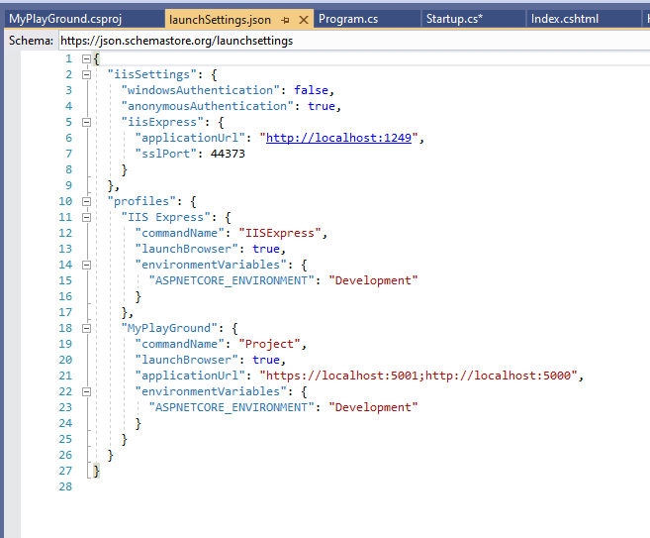

Program.cs

* Here we call the CreateDefaultBuilder method which returns the initialized builder object. This is initialized with default configuration. 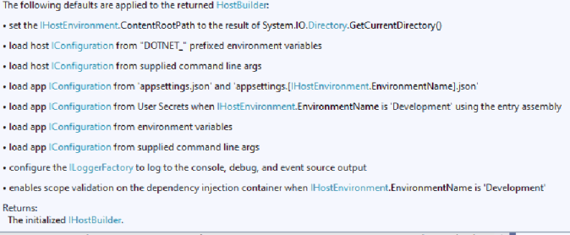

Startup.cs

* It loads the configuration via Dependency Injection.
* Its two important methods are ConfigureServices() and Configure().
  + **ConfigureServices()** : This method we configure all the services that are used. Its basically used to add all the dependencies that we will use in our application.
  + **Configure()** : is used as a middleware of the application. Every HTTP call that is used in this application will be returned over here. We can configure any custom middleware here too, for that we need to use **app.use()**  method.